UNITED STATES
SECURITIES AND EXCHANGE COMMISSION
Washington, D.C. 20549
SCHEDULE 14A INFORMATION

Proxy Statement Pursuant to Section 14(a) of the
Securities Exchange Act of 1934 (Amendment No. )
Filed by the Registrant ☒ | Filed by a Party other than the Registrant ☐
Check the appropriate box:
☐ | Preliminary Proxy Statement
☐ | Confidential, for Use of the Commission Only (as permitted by Rule 14a-6(e)(2))
☐ | Definitive Proxy Statement
☒ | Definitive Additional Materials
☐ | Soliciting Material under §240.14a-12
DISC MEDICINE, INC.
(Name of Registrant as specified in its charter)
(Name of Person(s) Filing Proxy Statement, if other than the Registrant)
Payment of Filing Fee (Check all boxes that apply):
☒ | No fee required.
☐ | Fee paid previously with preliminary materials.
☐ | Fee computed on table in exhibit required by Item 25(b) per Exchange Act Rules 14a-6(i)(1) and 0-11.

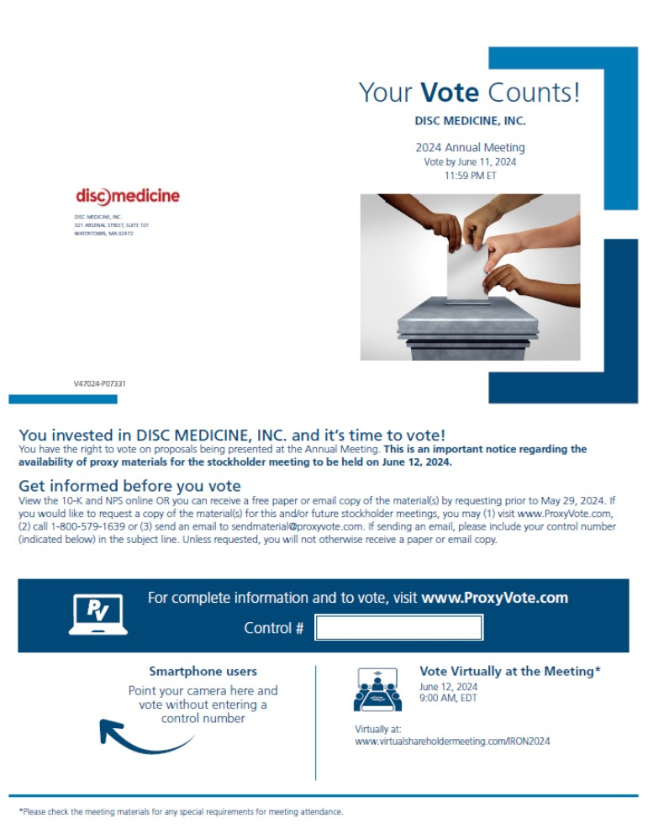
Your Vote Counts! DISC MEDICINE, INC. 321 ARSENAL STREET, SUITE 101 WATERTOWN, MA 02472 DISC MEDICINE, INC. 2023 Annual Meeting Vote by June 8, 2023 11:59 PM ET disc medicine V09882-P92820 You invested in DISC MEDICINE, INC. and it’s time to vote! You have the right to vote on proposals being presented at the Annual Meeting. This is an important notice regarding the availability of proxy materials for the stockholder meeting to be held on June 9, 2023. *Please check the meeting materials for any special requirements for meeting attendance. Smartphone users Point your camera here and vote without entering a control number For complete information and to vote, visit www.ProxyVote.com Control # V09882-P92820 Get informed before you vote View the 10-K and NPS online OR you can receive a free paper or email copy of the material(s) by requesting prior to May 26, 2023. If you would like to request a copy of the material(s) for this and/or future stockholder meetings, you may (1) visit www.ProxyVote.com, (2) call 1-800-579-1639 or (3) send an email to sendmaterial@proxyvote.com. If sending an email, please include your control number (indicated below) in the subject line. Unless requested, you will not otherwise receive a paper or email copy Vote Virtually at the Meeting* June 9, 2023 9:00 AM, EDT Virtually at: www.virtualshareholdermeeting.com/IRON2023

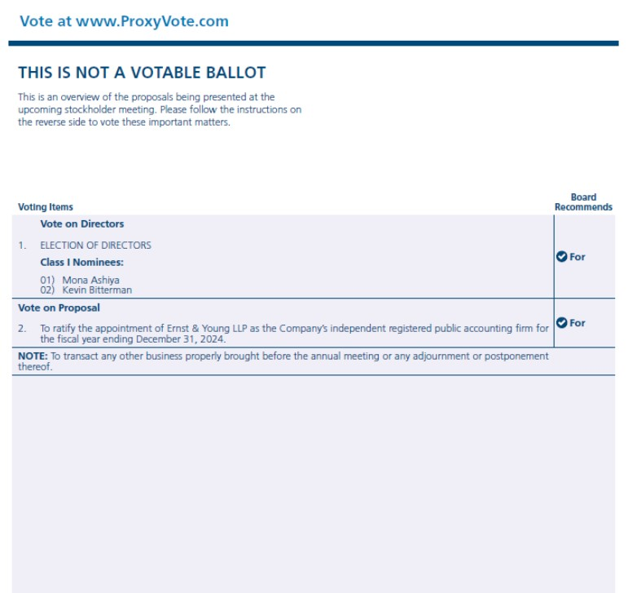
Vote at www.ProxyVote.com THIS IS NOT A VOTABLE BALLOT This is an overview of the proposals being presented at the upcoming stockholder meeting. Please follow the instructions on the reverse side to vote these important matters. Voting Items Board Recommends 1. Election of Directors Class II Nominees: 01) Georges Gemayel 02) Mark Chin 03) Liam Ratcliffe Class III Nominees: 04) Donald Nicholson 05) William White 06) John Quisel 2. To ratify the appointment of Ernst & Young LLP as the Company’s independent registered public accounting firm for the fiscal year ending December 31, 2023. NOTE: To transact any other business properly brought before the annual meeting or any adjournment or postponement thereof. For For Prefer to receive an email instead? While voting on www.ProxyVote.com, be sure to click “Delivery Settings”. V09883-P92820

